TITLE: E-commerce App

Problem Statement: Build an artisanal e-commerce platform using IBM Cloud Foundry. Connect skilled artisans with a global audience. Showcase handmade products, from exquisite jewelry to artistic home decor. Implement secure shopping carts, smooth payment gateways, and an intuitive checkout process. Nurture creativity and support small businesses through an artisan's dream marketplace!

Design Thinking:

Platform Design: Design the platform layout with sections for product categories, individual product pages, shopping cart, checkout, and payment.

Product Showcase: Create a database to store product information such as images, descriptions, prices, and categories.

User Authentication: Implement user registration and authentication features to enable artisans and customers to access the platform.

Shopping Cart and Checkout: Design and develop the shopping cart functionality and a smooth checkout process.

Payment Integration: Integrate secure payment gateways to facilitate transactions.

User Experience: Focus on providing an intuitive and visually appealing user experience for both artisans and customers.

To build a project in ibm cloud foundry

Here,application using ibm

STEP1: create an ibm cloud account

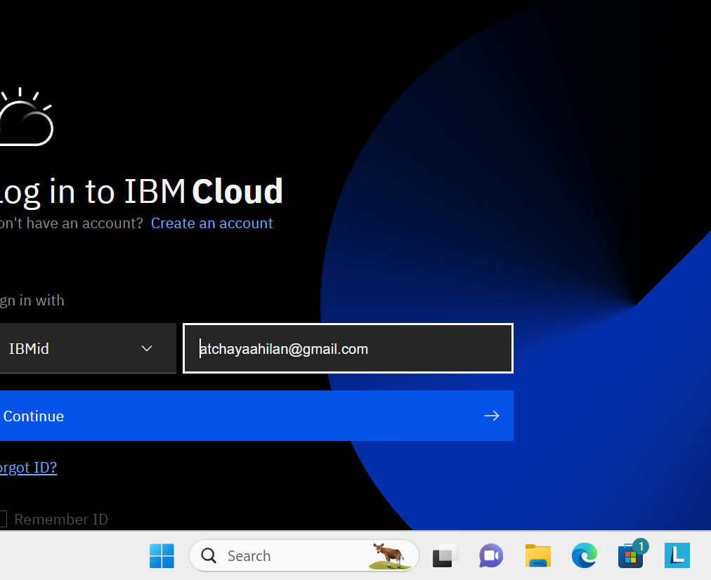

STEP2: dash board will appear like this

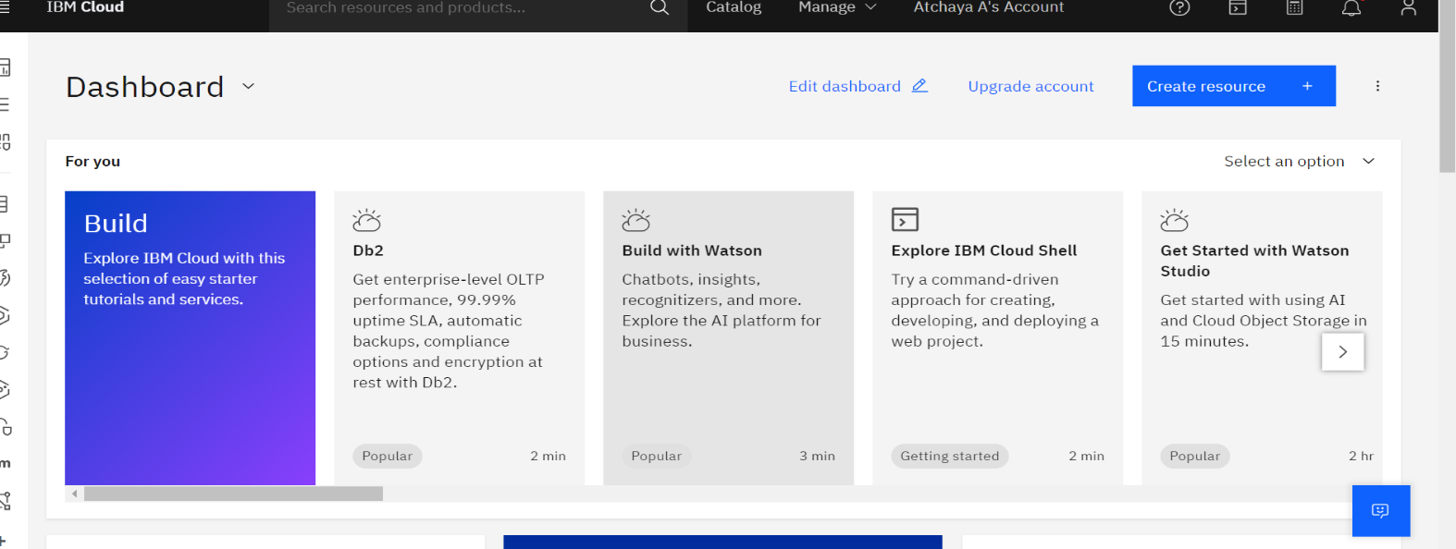

STEP3: dash board…manage our account

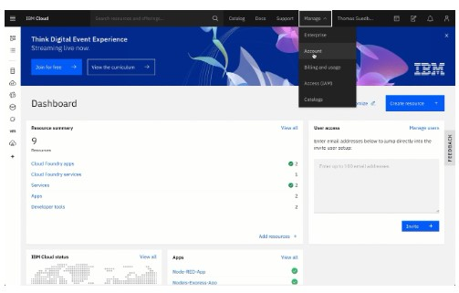

STEP 4: enter the details..

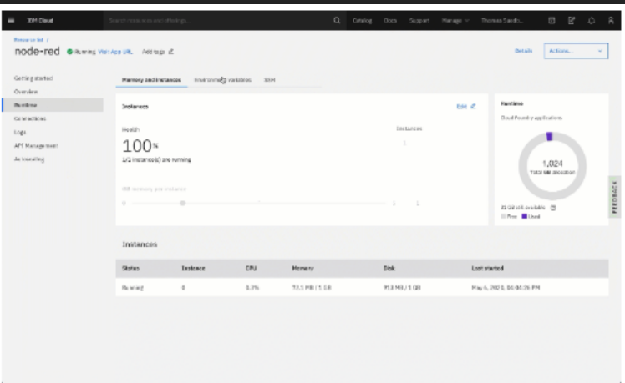

STEP5: building application

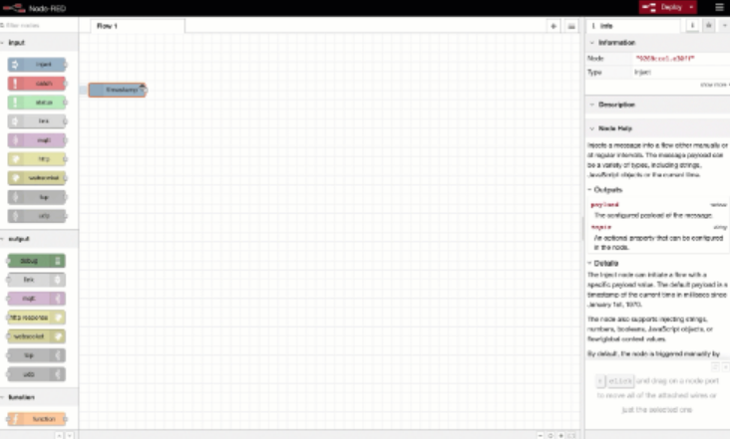

STEP6:application is formed

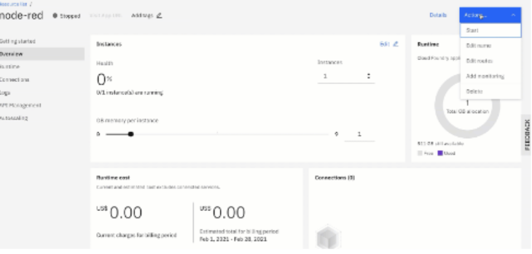

Step 7:create an e commerce platform.

In this we are creating “ORANGE STORE”

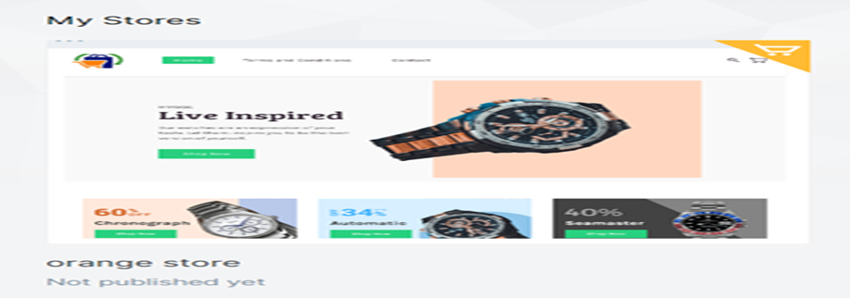

STEP 8:dash board for our app appears..

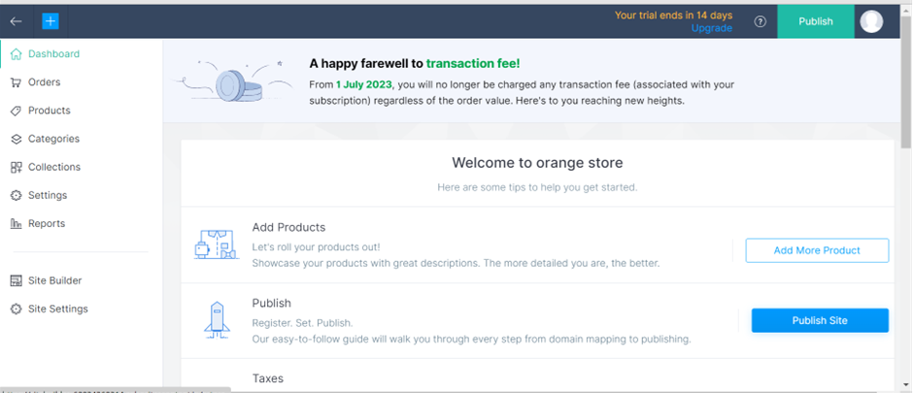

STEP9: Add product details…on selling price and retail price the details

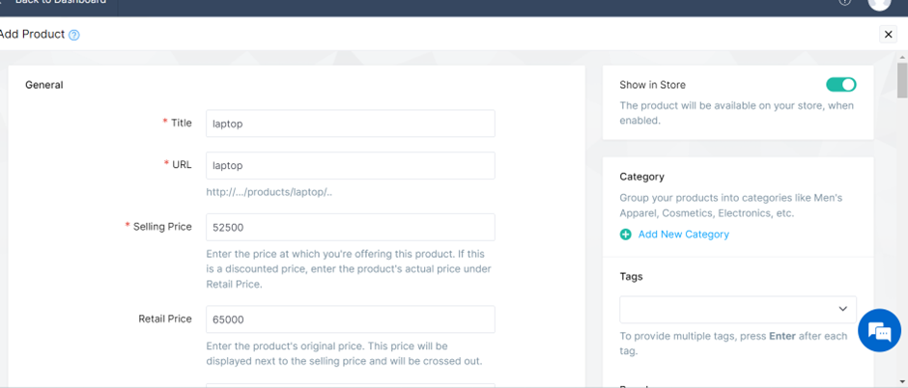

STEP10:go to products collection pg and check

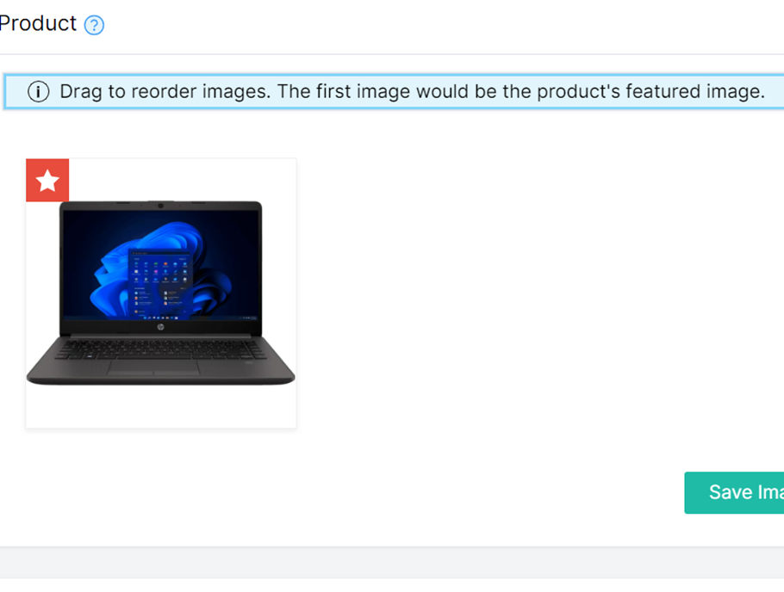

Step 11:we can publish by clicking publish…we can sell our products.

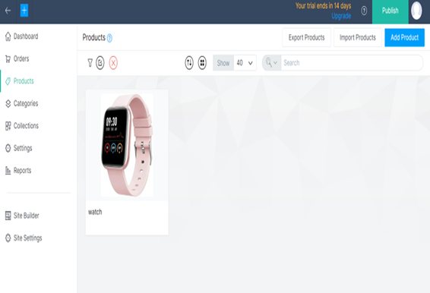

Step 12: our store is ready ..

CONCLUSION:

The business to consumer aspect of electronic commerce (e-commerce) is the most visible business use of the Word Wide Web. The primary goal of an e-commerce site is to sell goods and services online.